**Motor nerves conduction**

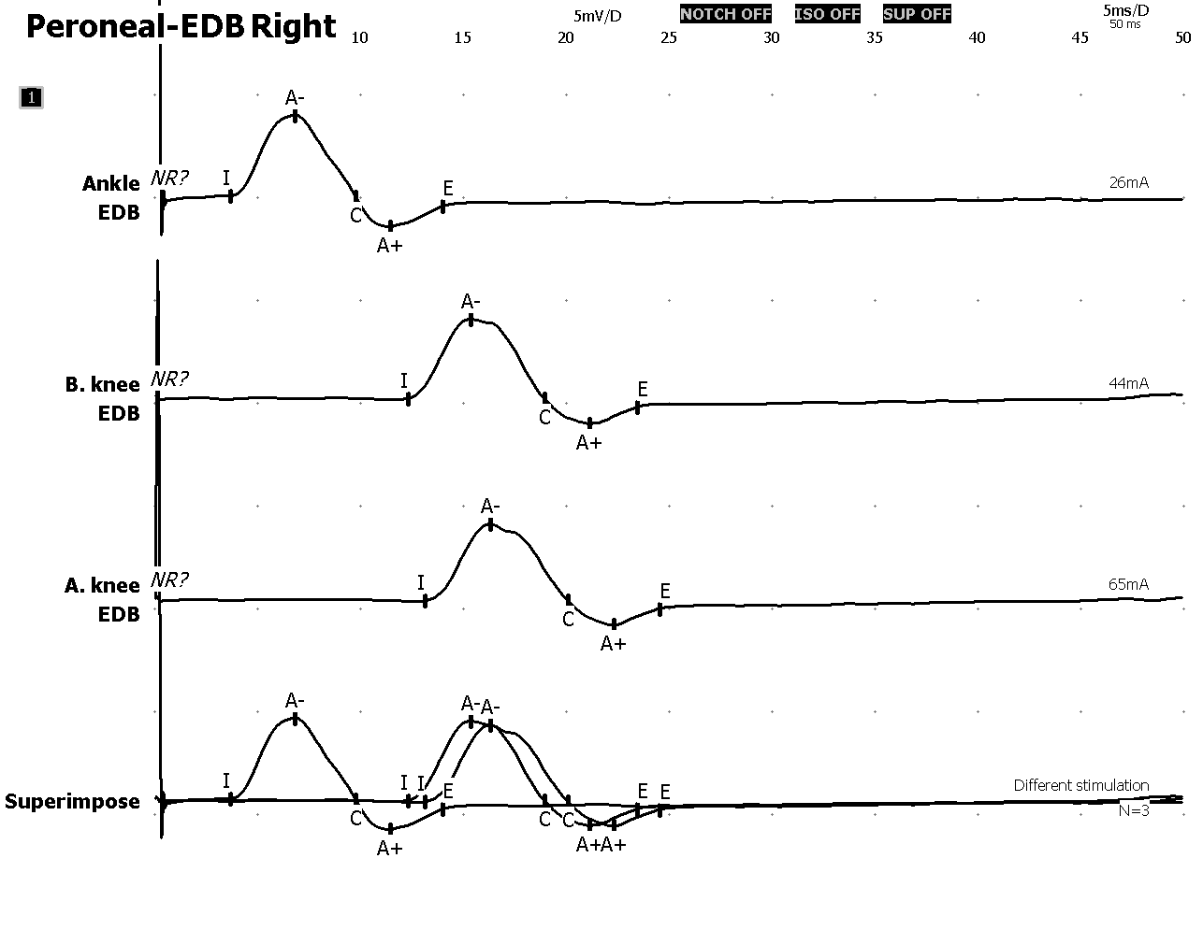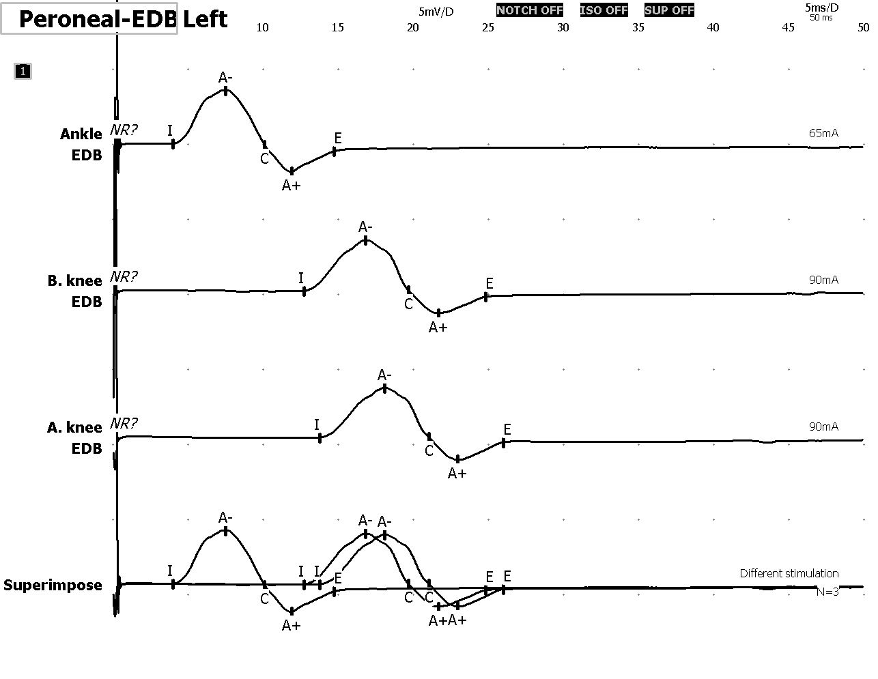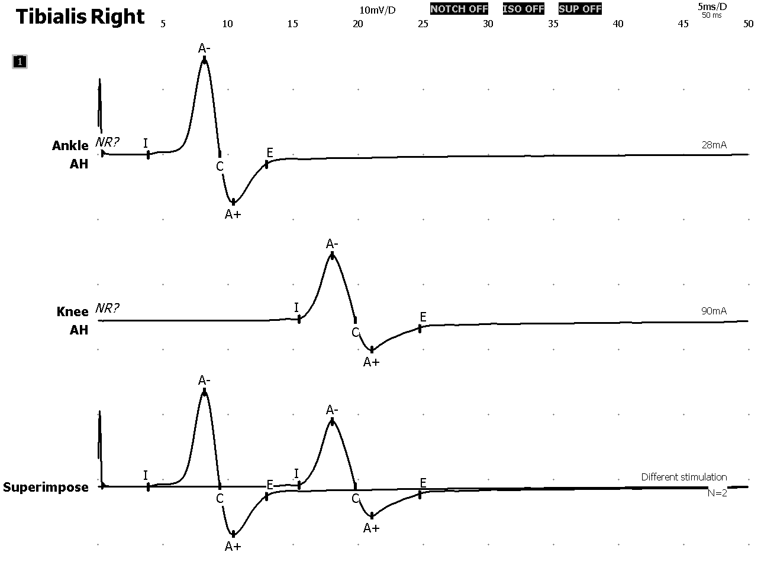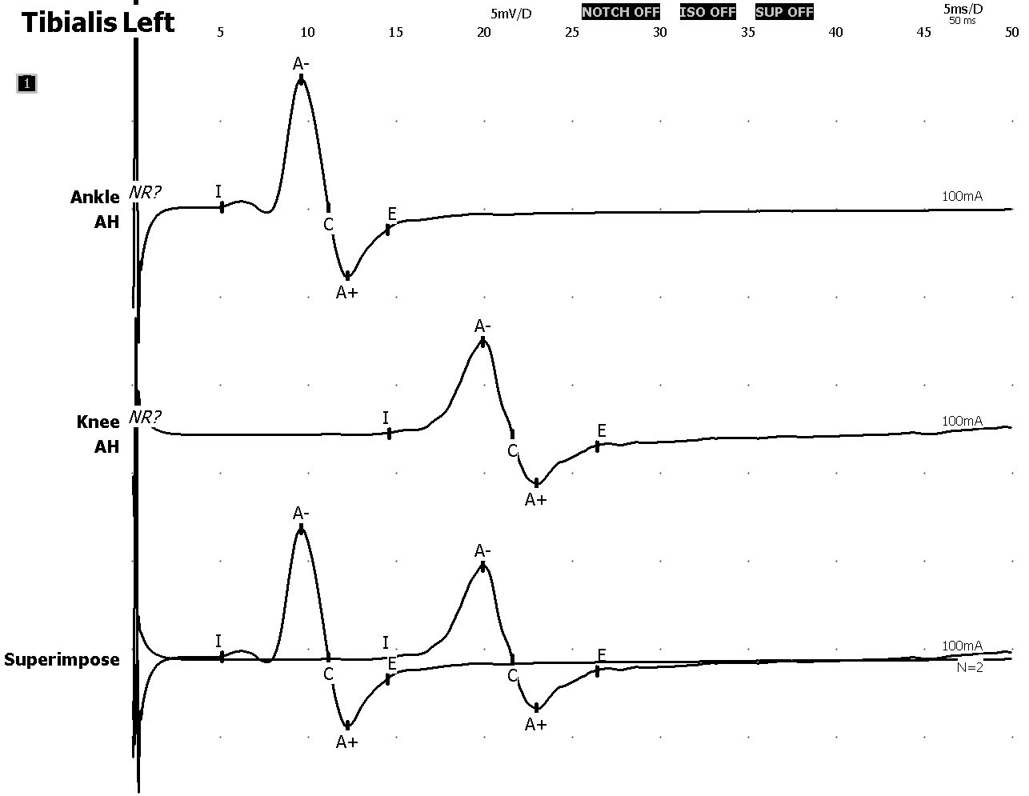

|  |  |  |  |  |  |  |
| --- | --- | --- | --- | --- | --- | --- |
| **Motor nerves conduction** | | | | | | |
|  | **Segment** | **Latency [ms]** | **Amplitude [mV]** | **Conduction**  **velocity [m/s]** | **Amplitude % [%]** | **Distance [mm]** |
| Peroneal- Extensor digitorum brevis right | Ankle-Extensor digitorum brevis/B. knee-Ankle/A. knee-B. knee | 3.7/12.3/13.1 | 3.9/3.9/3.7 | -/44/63 | -/-2.2/-2.9 | 70/380/50 |
| Peroneal- Extensor digitorum brevis left | Ankle-Extensor digitorum brevis/B. knee-ankle/A. knee-B. knee | 4.0/12.7/13.8 | 3.6/3.4/3.3 | -/44/48 | -/-4.9/-2.0 | 70/380/50 |
| Tibialis right | Ankle-Adductor hallucis/Knee-Ankle | 3.9(-2.0σ)˟/15.4 | 14.6(-0.5σ)/9.9 | -/55(2.6σ)* | -/-32.5(0.7σ) | 90/410 |
| Tibialis left | Ankle-Adductor hallucis/Knee-Ankle | 5.1(-0.4σ)/14.6 | 7.3(1.4σ)/5.2 | -/43(0.7σ) | -/-28.2(0.4σ) | 90/410 |

**Sensory nerves conduction**

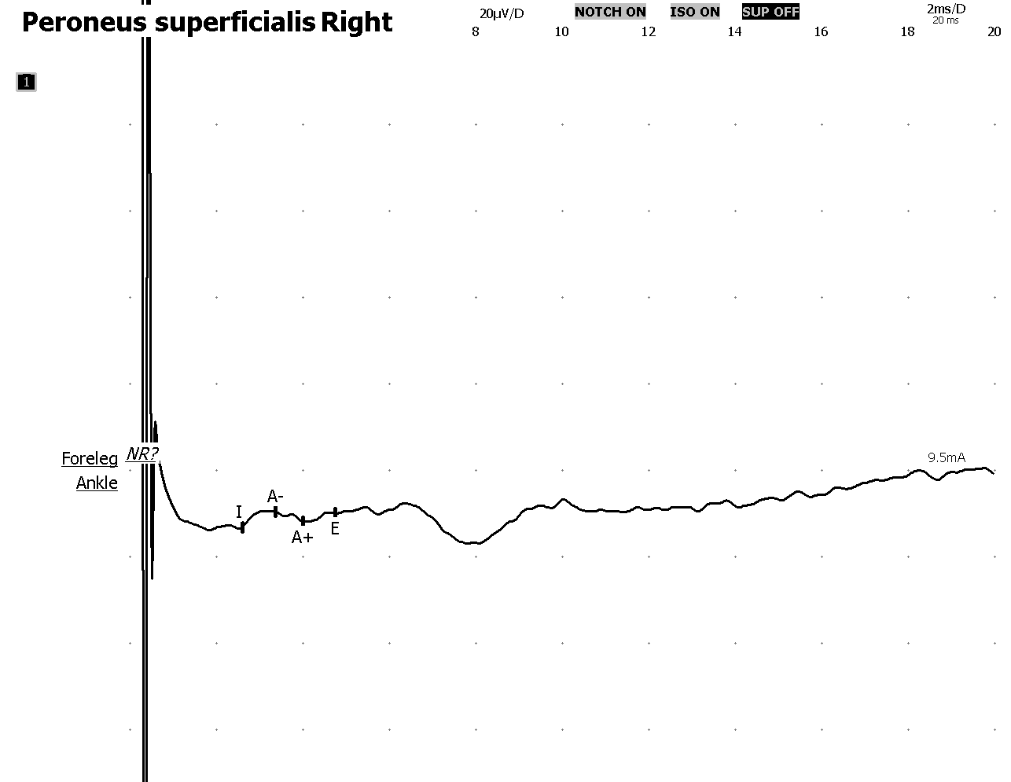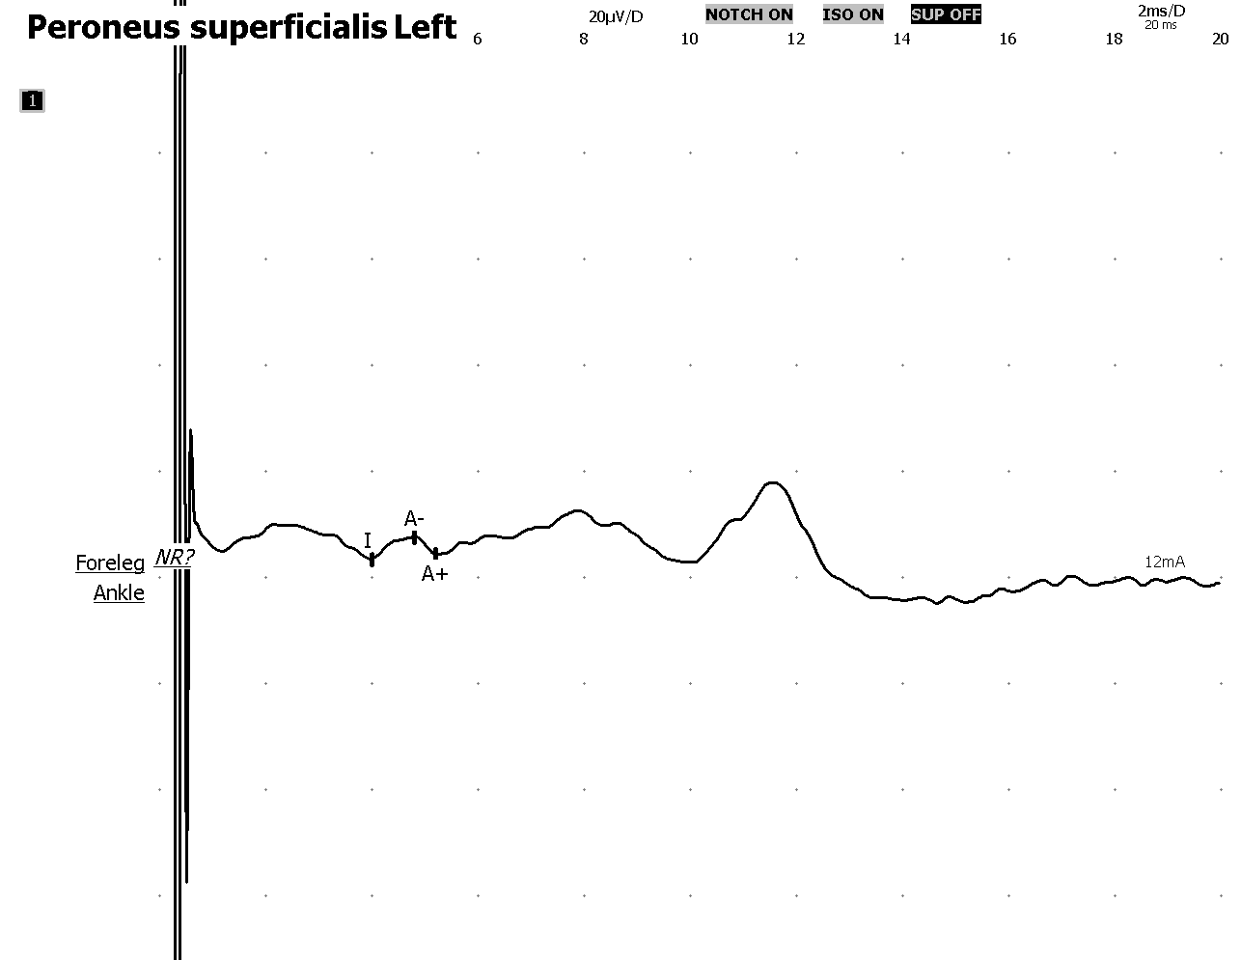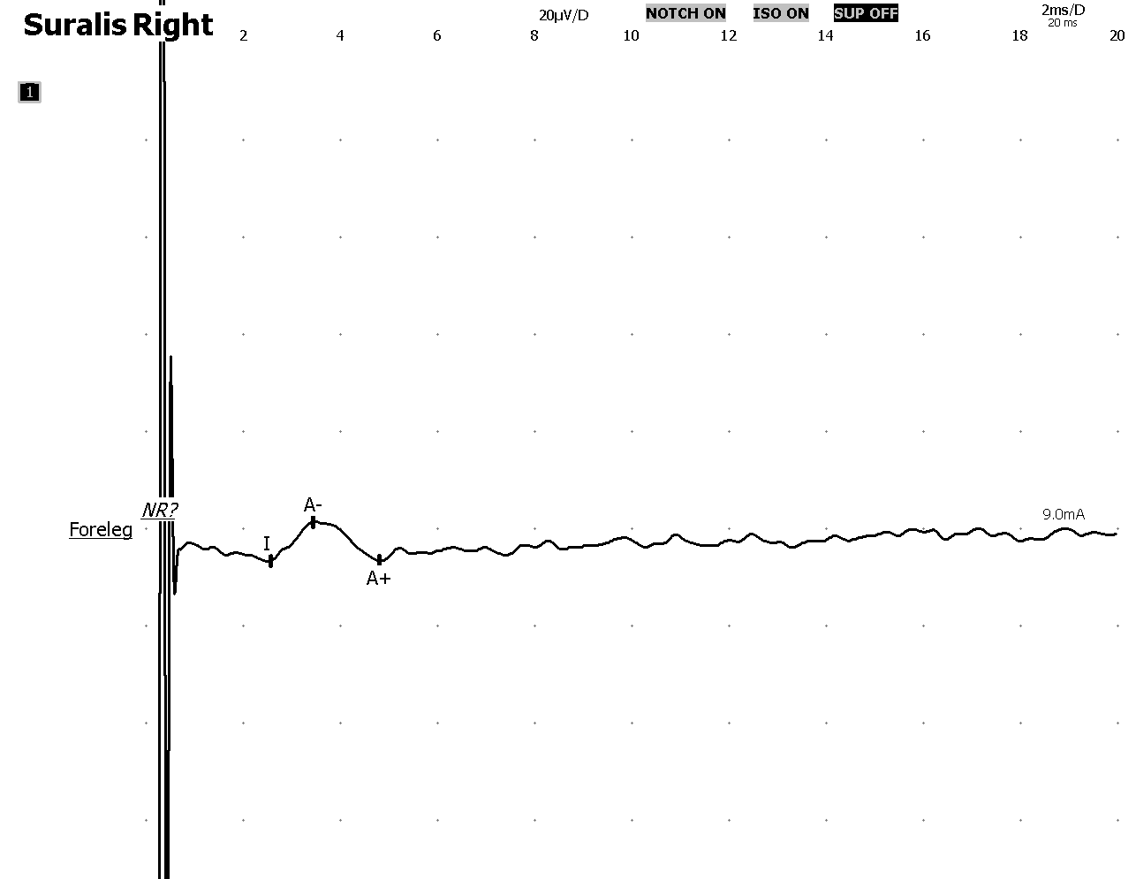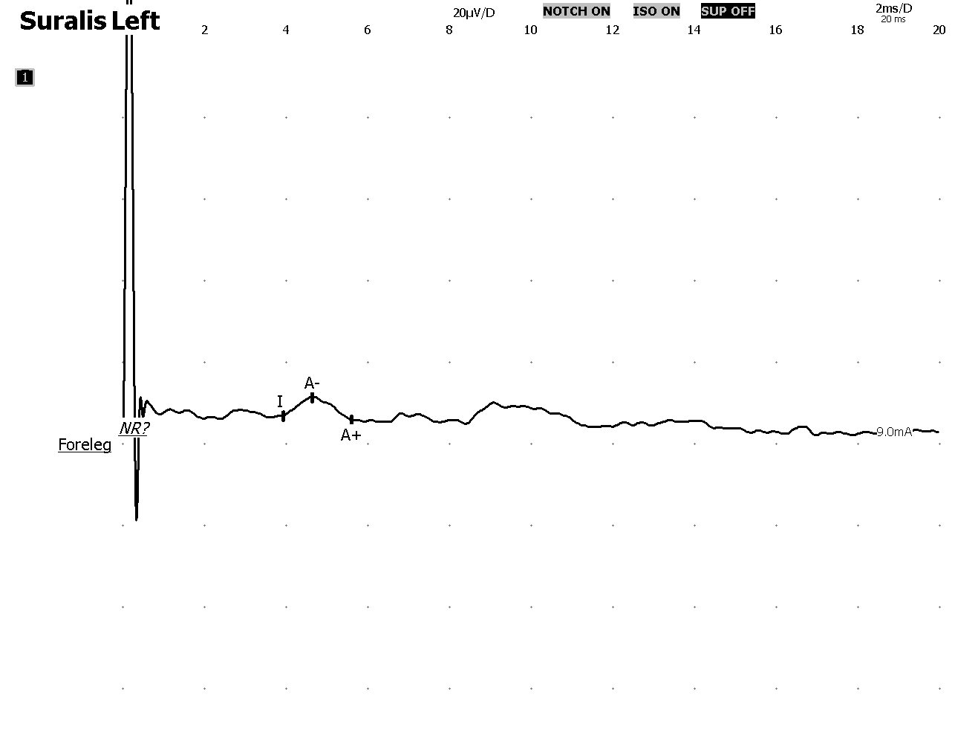

|  |  |  |  |  |  |
| --- | --- | --- | --- | --- | --- |
| **Sensory nerves conduction** | | | | | |
|  | **Segment** | **Latency [ms]** | **Amplitude [µV]** | **Conduction velocity [m/s]** | **Distance [mm]** |
| Peroneus superficialis right | Foreleg-Ankle | 3.4 | 3.6(2.5σ)* | 38(0.7σ) | 100 |
| Peroneus superficialis left | Foreleg-Ankle | 4.8 | 4.1(2.2σ)* | - | - |
| Suralis right | - Foreleg | 3.4 | 8.1 | 43 | 110 |
| Suralis left | - Foreleg | 4.6 | 4.6 | 33 | 130 |

**EMG**

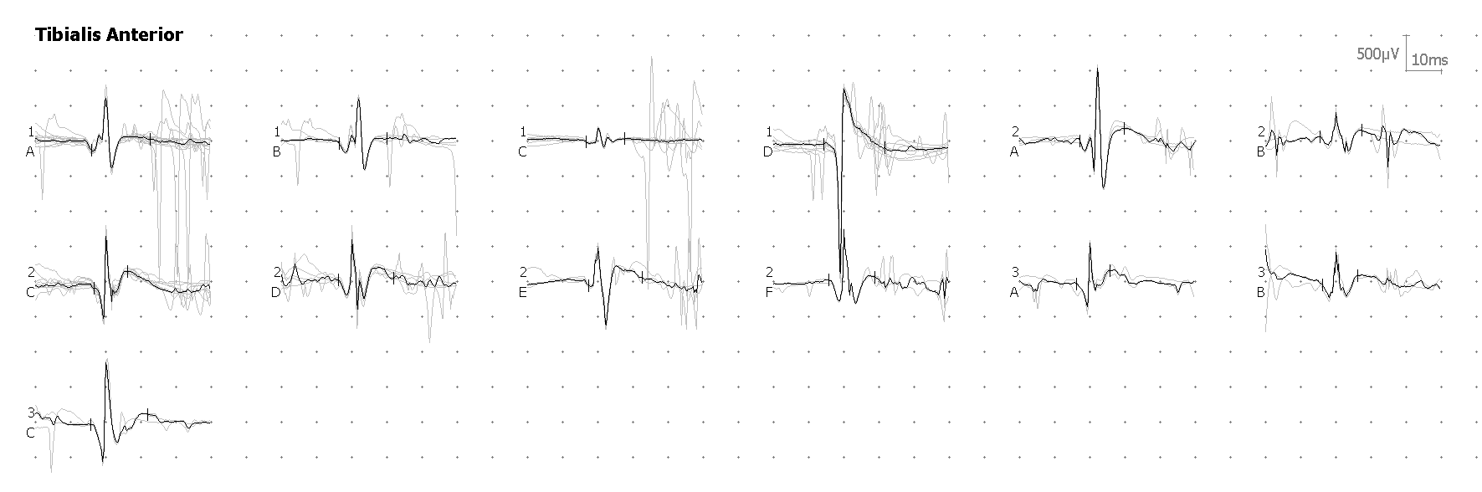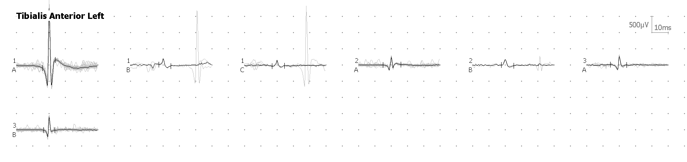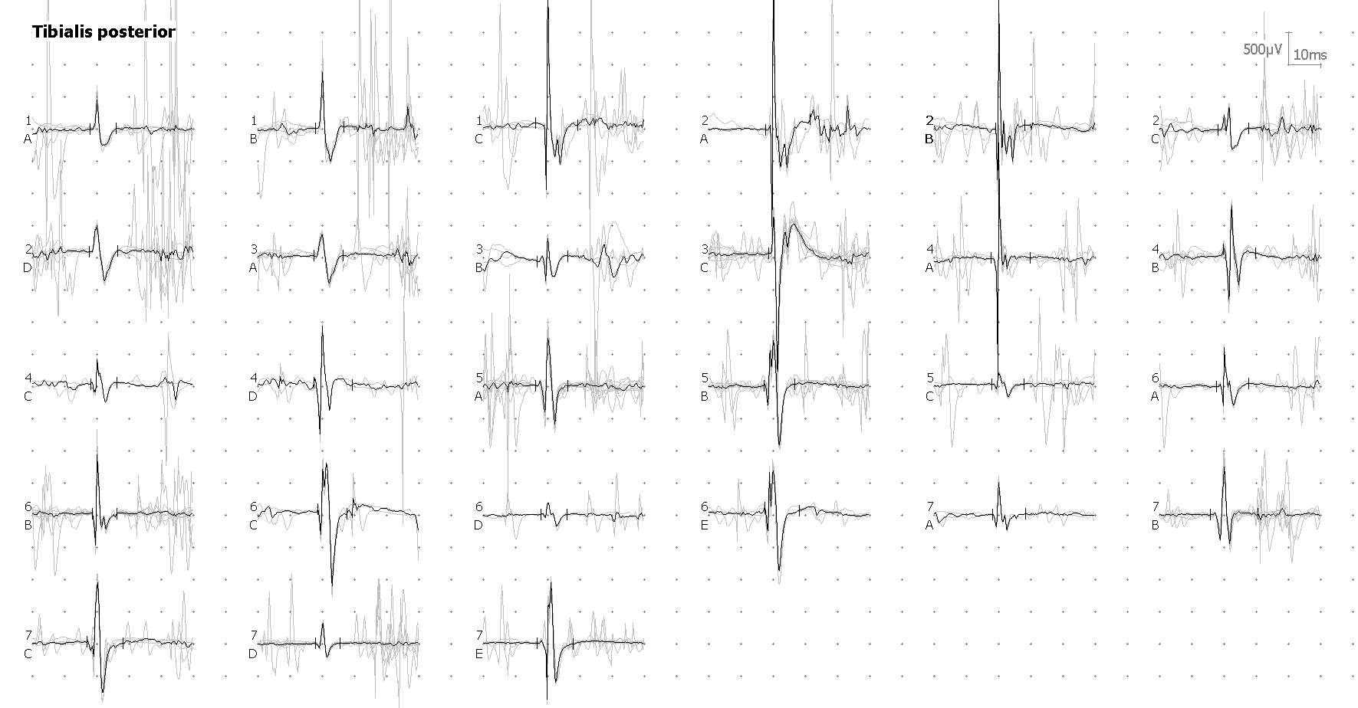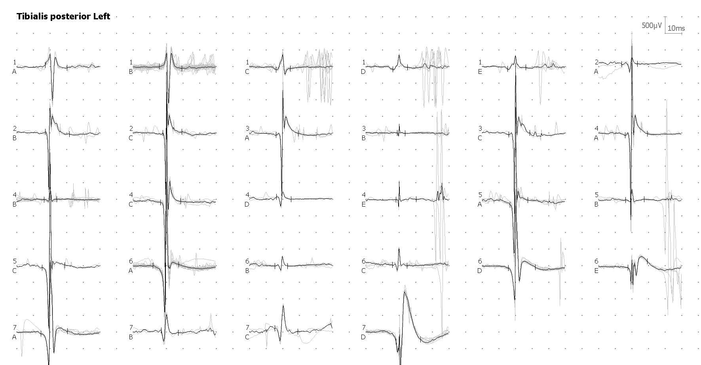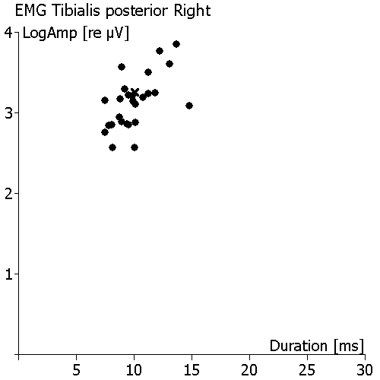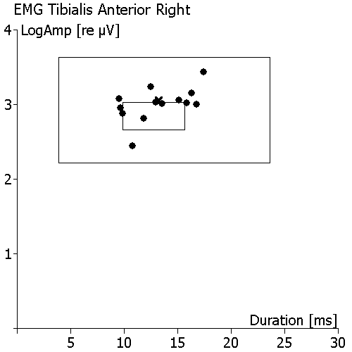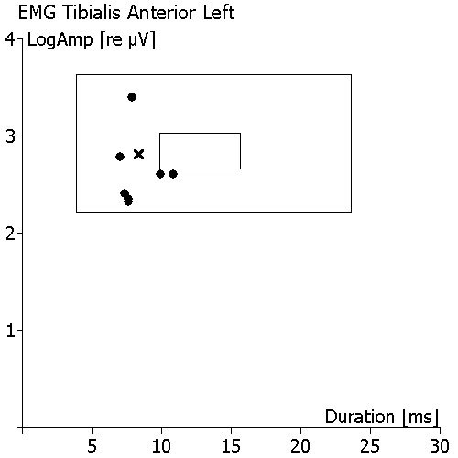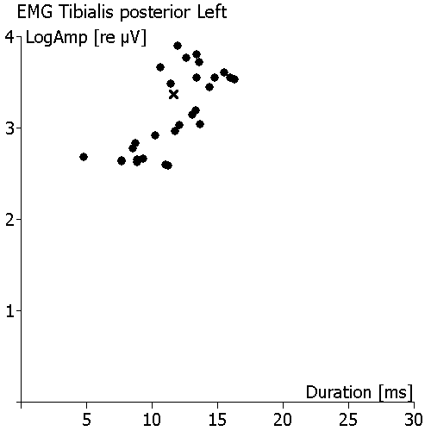

|  |  |  |  |  |  |  |  |  |  |
| --- | --- | --- | --- | --- | --- | --- | --- | --- | --- |
| **EMG - Average of motor unite potentials** | | | | | | | | | |
|  | **Duration [ms]** | **Amplitude [µV]** | **Turns** | **Phasis** | **Rise time [ms]** | **Spike duration [ms]** | **Area [µV*ms]** | **No. seg.** | **No. poly** |
| Tibialis anterior right | 10.2(9.9 - 15.7) | 648(455 - 1076) | 5 | 2.8 | 1.6 | 5 | 791(968 - 3206) | 6 | 0 |
| Tibialis anterior left | 11.3(9.9 - 15.7) | 1653(455 - 1076) | 3 | 1.9 | 1.5 | 4 | 1852(968 - 3206) | 15 | 0 |
| Tibialis posterior right | 10.1 | 816 | 5 | 2.8 | 0.9 | 3 | 841 | 6 | 1 |
| Tibialis posterior left | 11.6 | 2328 | 4 | 2.4 | 1.6 | 6 | 2642 | 7 | 0 |

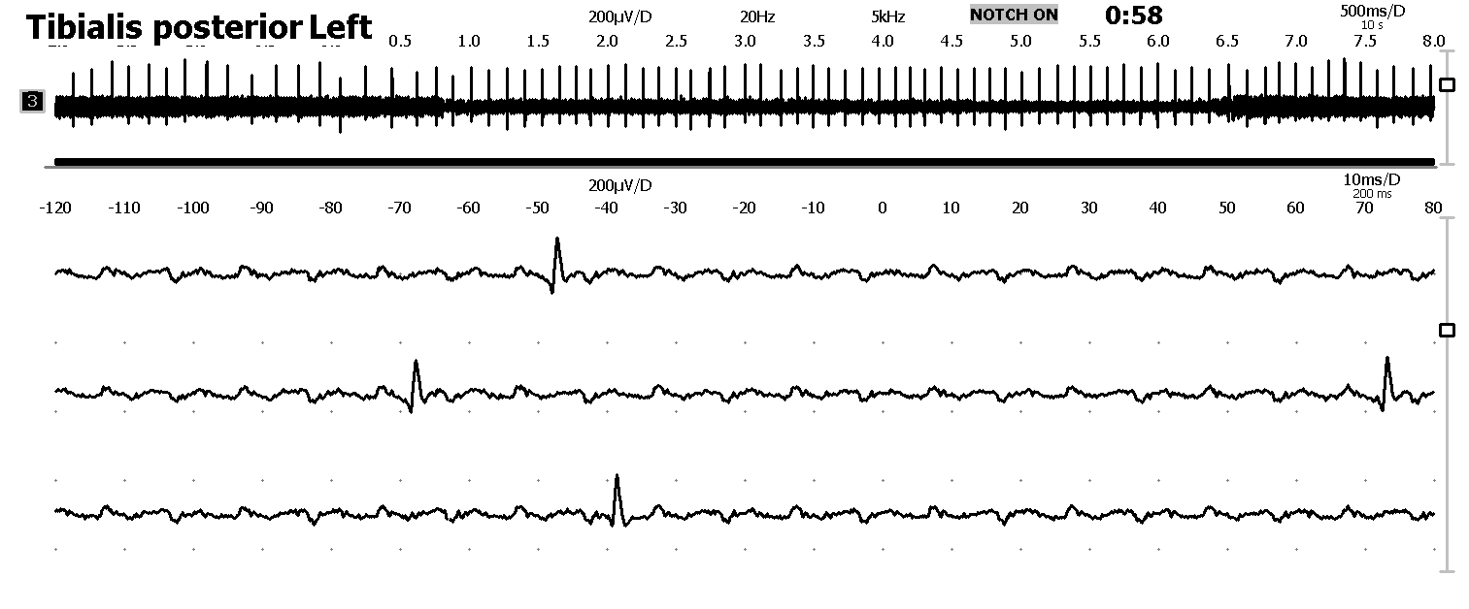

|  |  |  |  |  |  |  |  |  |  |  |  |  |  |
| --- | --- | --- | --- | --- | --- | --- | --- | --- | --- | --- | --- | --- | --- |
| **EMG Scoring** | | | | | | | | | | | | | |
| **Insertional activity** | **Spontaneous activities** | | | | | | **Voluntary activity** | | | | | | |
|  | **Fibrillation** | **Positive sharp waves** | **Fasciculation** | **Myotonic** | **Myokimy** | **Complex repetitive discharge** | **Amplitude** | **Duration** | **Polyphasy** | **Stability** | **IP** | **Recruitment** | **Effort** |
| Tibialis anterior - Left | | | | | | | | | | | | | |
| None | 2 | 2 | None | None | None | None | None | None | None | None | None | None | None |
| Tibialis posterior - Left | | | | | | | | | | | | | |
| None | 3 | 2 | None | None | None | None | +++ | +++ | None | None | None | Reduced | None |
| Tibialis posterior - Right | | | | | | | | | | | | | |
| None | None | none | None | None | None | None | None | None | None | None | None | None | None |
| Tibialis anterior - Right | | | | | | | | | | | | | |
| None | None | none | None | None | None | None | None | None | None | None | None | None | None |

**Suppl 1. NCS and needle EMG results of case 1.** DuringNCS on the nerves of the legs along the tibial and peroneal nerves, there is an asymmetry in amplitude along the tibial nerve on the left more than 40%, but the parameters are within normal limits for motor responses, symmetrical, reference values. For sensory responses, the parameters are normal, symmetrical. According to needle EMG: in the anterior and posterior tibial muscles, the MUAPs are increased in amplitude and duration by 20% of normal, in the abductor muscle of the thigh (L5 segment) there is a moderate increase in amplitude with normal duration of the MUAPs, spontaneous activities like positive sharp wave and fasciculation in the anterior and posterior tibial muscles on the left are a sign of an active neural reinvention-denervation process at the L4-5 level on the left (root), the process is active and acute.