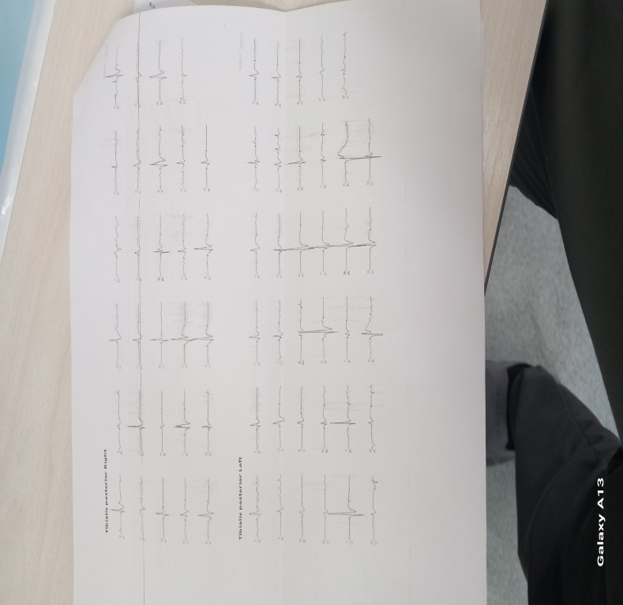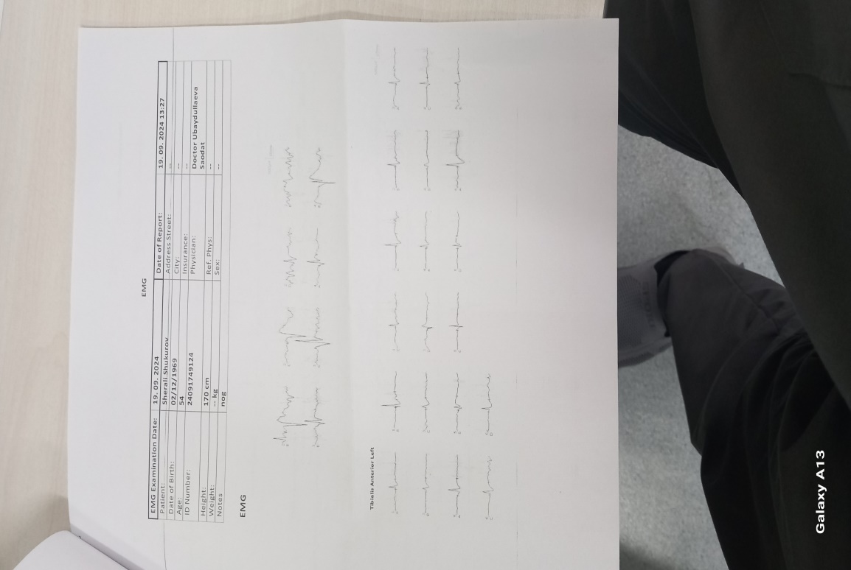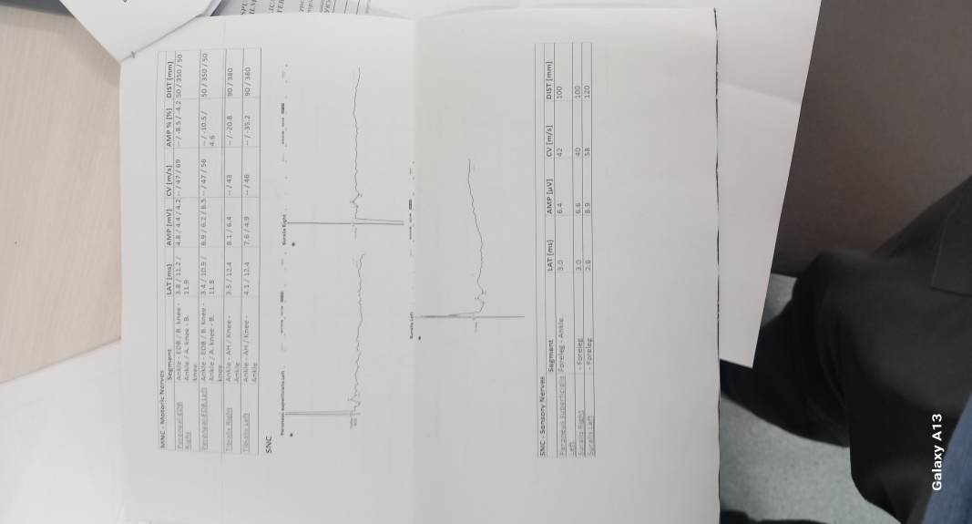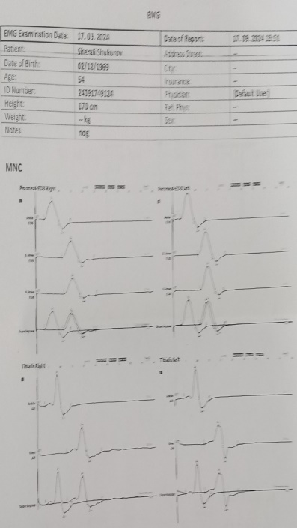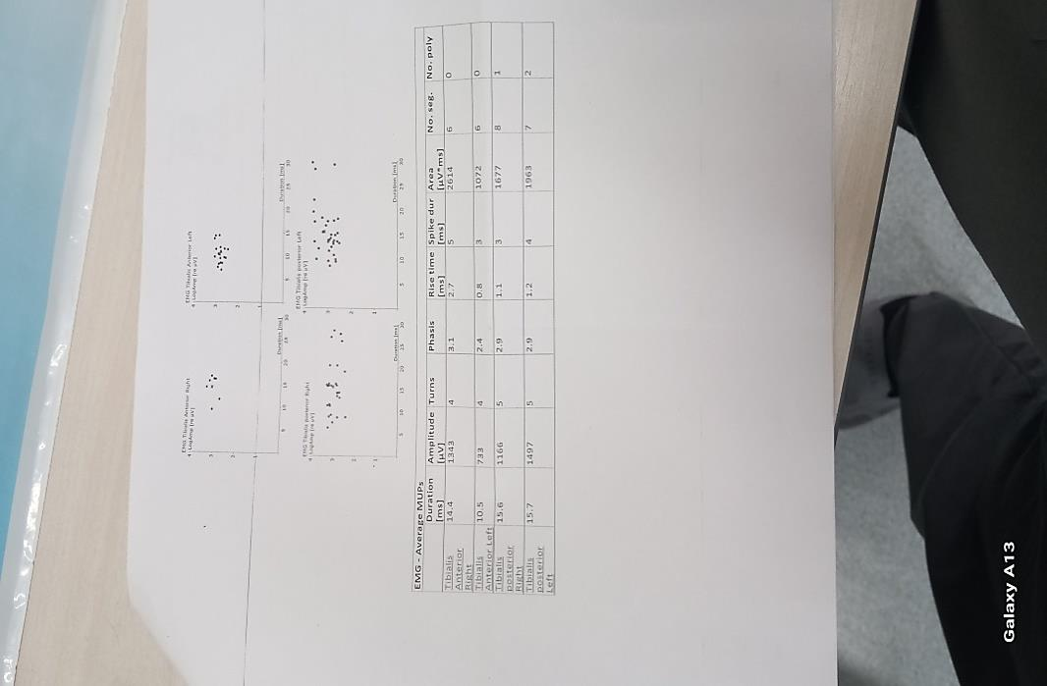

|  |  |  |  |  |  |  |
| --- | --- | --- | --- | --- | --- | --- |
| **Motor nerves conduction** | | | | | | |
|  | **Segment** | **Latency [ms]** | **Amplitude [mV]** | **Conduction velocity [m/s]** | **Amplitude % [%]** | **Distance [mm]** |
| Peroneal- Extensor digitorum brevis right | Ankle-Extensor digitorum brevis/B. knee-Ankle/A. knee-B. knee | 3.8/11.2/11.9 | 4.8/4.4/4.2 | -/47/69 | -/-8.5/-4.2 | 50/350/50 |
| Peroneal- Extensor digitorum brevis left | Ankle-Extensor digitorum brevis/B. knee-Ankle/A. knee-B. knee | 3.4/10.9/11.8 | 6.9/6.2/6.5 | -/47/56 | -/10.5/-4.6 | 50/350/50 |
| Tibialis right | Ankle-Adductor hallucis/Knee-Ankle | 3.5/12.4 | 8.1/6.4 | -/43 | -/20.8 | 90/380 |
| Tibialis left | Ankle-Adductor hallucis/Knee-Ankle | 4.1/12.4 | 7.6/4.9 | -/46 | -/35.2 | 90/380 |

|  |  |  |  |  |  |
| --- | --- | --- | --- | --- | --- |
| **Sensory nerves conduction** | | | | | |
|  | **Segment** | **Latency [ms]** | **Amplitude [µV]** | **Conduction velocity [m/s]** | **Distance [mm]** |
| Peroneus superficialis left | Foreleg-Ankle | 3.0 | 6.4 | 42 | 100 |
| Peroneus superficialis right | Foreleg-Ankle | 3 | 6.6 | 40 | 100 |
| Suralis right | - Foreleg | 2.6 | 8.9 | 58 | 120 |
| Suralis left | - Foreleg | 4.6 | 4.6 | 33 | 120 |

|  |  |  |  |  |  |  |  |  |  |
| --- | --- | --- | --- | --- | --- | --- | --- | --- | --- |
| **EMG - Average of motor unite potentials** | | | | | | | | | |
|  | **Duration [ms]** | **Amplitude [µV]** | **Turns** | **Phasis** | **Rise time [ms]** | **Spike dur [ms]** | **Area [µV*ms]** | **No. seg.** | **No. polyphasy** |
| Tibialis anterior right | 14.4 | 1343 | 4 | 3.1 | 2.7 | 5 | 2614 | 6 | 0 |
| Tibialis anterior left | 10.5 | 733 | 4 | 2.4 | 0.8 | 3 | 1072 | 6 | 0 |
| Tibialis posterior right | 15.6 | 1166 | 5 | 2.9 | 1.1 | 3 | 1677 | 8 | 1 |
| Tibialis posterior left | 15.7 | 1497 | 5 | 2.9 | 1.2 | 4 | 1963 | 7 | 2 |

**Suppl 2. NCS and needle EMG results of case 2.** DuringNCS on the nerves of the legs along the tibial and peroneal nerves there had not been found any anomalies on motor and sensory parts. According to needle EMG: in the posterior tibial muscle, an increased amplitude of MUAPs was found on the left, while other muscles were normal. Spontaneous activities were not observed. Mildly radicular process could be seen on the left.