# Suppl 1.

Basic flowchart for every Analysis conducted thorough TriNetX for this paper:

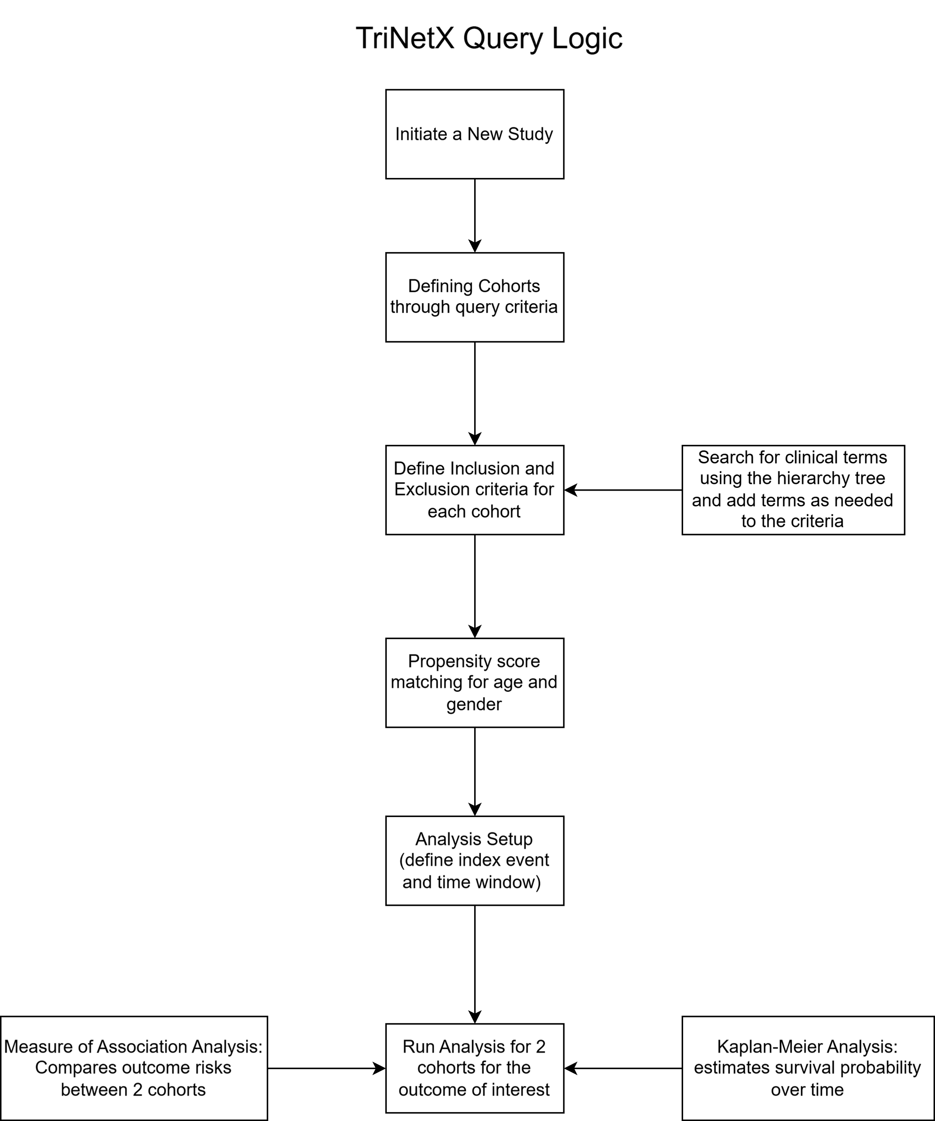

**Analysis basics with specified cohort data for each set of analyses**

**Query Criteria for Cohort 1 (query name: Calcium channel blockers)**

This query was run on the network Research with 95 HCO(s) queried and 95 HCO(s) responded. A total of 84 provider(s) responded with patients. The final cohort included 385,542 patients who matched the query criteria listed in the table below.

**Cohort 1 (CCB) Inclusion criteria and exclusion tables**

|  |  |  |  |  |  |
| --- | --- | --- | --- | --- | --- |
| Group 1 | | | | | |
|  | **Group 1A** | | | | |
|  | must have |  | diagnosis | UMLS:ICD10CM:I10 | Essential (primary) hypertension |
|  | date constraint | | The terms in this group occurred on or before Dec 31, 2018 | | |
|  | event relationship | | Any instance of Group 1B occurred on or after any instance of Group 1A | | |
|  | **Group 1B** | | | | |
|  | must have |  | medication | NLM:VA:CV200 | CALCIUM CHANNEL BLOCKERS |
| Group 2 | | | | | |
|  | **Group 2A** | | | | |
|  | cannot have |  | diagnosis | UMLS:ICD10CM:F03 | Unspecified dementia |
|  |  | or | diagnosis | UMLS:ICD10CM:F02.80 | Dementia in other diseases classified elsewhere, unspecified severity, without behavioral disturbance, psychotic disturbance, mood disturbance, and anxiety |
|  |  | or | diagnosis | UMLS:ICD10CM:I60-I69 | Cerebrovascular diseases |
|  |  | or | medication | NLM:ATC:C07 | BETA BLOCKING AGENTS |
|  |  | or | medication | NLM:VA:CV701 | THIAZIDES/RELATED DIURETICS |
|  |  | or | medication | NLM:VA:CV800 | ACE INHIBITORS |
|  |  | or | procedure | UMLS:HCPCS:G8506 | Patient receiving angiotensin converting enzyme (ace) inhibitor or angiotensin receptor blocker (arb) therapy |
|  |  | or | medication | NLM:VA:CV800 | ACE INHIBITORS |
|  | date constraint | | The terms in this group occurred at any time | | |

**Query Criteria for Cohort 2 (query name: Beta blockers)**

This query was run on the network Research with 95 HCO(s) queried and 94 HCO(s) responded. A total of 81 provider(s) responded with patients. The final cohort included 716,717 patients who matched the query criteria listed in the table below.

**Cohort 2 (BB) Inclusion and Exclusion criteria table**

|  |  |  |  |  |  |
| --- | --- | --- | --- | --- | --- |
| Group 1 | | | | | |
|  | **Group 1A** | | | | |
|  | must have |  | diagnosis | UMLS:ICD10CM:I10 | Essential (primary) hypertension |
|  | date constraint | | The terms in this group occurred on or before Dec 31, 2018 | | |
|  | event relationship | | Any instance of Group 1B occurred on or after any instance of Group 1A | | |
|  | **Group 1B** | | | | |
|  | must have |  | medication | NLM:VA:CV100 | BETA BLOCKERS/RELATED |
| Group 2 | | | | | |
|  | **Group 2A** | | | | |
|  | cannot have |  | medication | NLM:VA:CV200 | CALCIUM CHANNEL BLOCKERS |
|  |  | or | diagnosis | UMLS:ICD10CM:F03 | Unspecified dementia |
|  |  | or | diagnosis | UMLS:ICD10CM:F02.80 | Dementia in other diseases classified elsewhere, unspecified severity, without behavioral disturbance, psychotic disturbance, mood disturbance, and anxiety |
|  |  | or | diagnosis | UMLS:ICD10CM:I60-I69 | Cerebrovascular diseases |
|  |  | or | medication | NLM:VA:CV701 | THIAZIDES/RELATED DIURETICS |
|  |  | or | medication | NLM:VA:CV800 | ACE INHIBITORS |
|  |  | or | procedure | UMLS:HCPCS:G8506 | Patient receiving angiotensin converting enzyme (ace) inhibitor or angiotensin receptor blocker (arb) therapy |
|  |  | or | medication | NLM:VA:CV800 | ACE INHIBITORS |
|  | date constraint | | The terms in this group occurred at any time | | |

**Cohort 3 (Dihydropyridine) inclusion and exclusion criteria:**

|  |  |  |  |  |  |
| --- | --- | --- | --- | --- | --- |
| Group 1 | | | | | |
|  | **Group 1A** | | | | |
|  | must have |  | diagnosis | UMLS:ICD10CM:I10 | Essential (primary) hypertension |
|  | date constraint | | The terms in this group occurred on or before Dec 31, 2018 | | |
|  | event relationship | | Any instance of Group 1B occurred on or after any instance of Group 1A | | |
|  | **Group 1B** | | | | |
|  | must have | any of | medication | NLM:RXNORM:7417 | nifedipine |
|  |  |  | medication | NLM:RXNORM:17767 | amlodipine |
|  |  |  | medication | NLM:RXNORM:4316 | felodipine |
|  |  |  | medication | NLM:RXNORM:7396 | nicardipine |
| Group 2 | | | | | |
|  | **Group 2A** | | | | |
|  | cannot have |  | diagnosis | UMLS:ICD10CM:F03 | Unspecified dementia |
|  |  | or | diagnosis | UMLS:ICD10CM:F02.80 | Dementia in other diseases classified elsewhere, unspecified severity, without behavioral disturbance, psychotic disturbance, mood disturbance, and anxiety |
|  |  | or | medication | NLM:RXNORM:3443 | diltiazem |
|  |  | or | medication | NLM:RXNORM:11170 | verapamil |
|  |  | or | diagnosis | UMLS:ICD10CM:I60-I69 | Cerebrovascular diseases |
|  |  | or | medication | NLM:ATC:C07 | BETA BLOCKING AGENTS |
|  |  | or | medication | NLM:VA:CV701 | THIAZIDES/RELATED DIURETICS |
|  |  | or | medication | NLM:VA:CV800 | ACE INHIBITORS |
|  |  | or | procedure | UMLS:HCPCS:G8506 | Patient receiving angiotensin converting enzyme (ace) inhibitor or angiotensin receptor blocker (arb) therapy |
|  |  | or | medication | NLM:VA:CV800 | ACE INHIBITORS |
|  |  | or | medication | NLM:RXNORM:3443 | diltiazem |
|  |  | or | medication | NLM:RXNORM:11170 | verapamil |
|  | date constraint | | The terms in this group occurred at any time | | |

**Cohort 4 (non-dihydropyridine) inclusion and exclusion criteria**

|  |  |  |  |  |  |
| --- | --- | --- | --- | --- | --- |
| Group 1 | | | | | |
|  | **Group 1A** | | | | |
|  | must have |  | diagnosis | UMLS:ICD10CM:I10 | Essential (primary) hypertension |
|  | date constraint | | The terms in this group occurred on or before Dec 31, 2018 | | |
|  | event relationship | | Any instance of Group 1B occurred on or after any instance of Group 1A | | |
|  | **Group 1B** | | | | |
|  | must have | any of | medication | NLM:RXNORM:3443 | diltiazem |
|  |  |  | medication | NLM:RXNORM:11170 | verapamil |
| Group 2 | | | | | |
|  | **Group 2A** | | | | |
|  | cannot have |  | diagnosis | UMLS:ICD10CM:F03 | Unspecified dementia |
|  |  | or | medication | NLM:RXNORM:7396 | nicardipine |
|  |  | or | medication | NLM:RXNORM:4316 | felodipine |
|  |  | or | diagnosis | UMLS:ICD10CM:F02.80 | Dementia in other diseases classified elsewhere, unspecified severity, without behavioral disturbance, psychotic disturbance, mood disturbance, and anxiety |
|  |  | or | medication | NLM:RXNORM:7417 | nifedipine |
|  |  | or | medication | NLM:RXNORM:17767 | amlodipine |
|  |  | or | diagnosis | UMLS:ICD10CM:I60-I69 | Cerebrovascular diseases |
|  |  | or | medication | NLM:ATC:C07 | BETA BLOCKING AGENTS |
|  |  | or | medication | NLM:VA:CV701 | THIAZIDES/RELATED DIURETICS |
|  |  | or | medication | NLM:VA:CV800 | ACE INHIBITORS |
|  |  | or | procedure | UMLS:HCPCS:G8506 | Patient receiving angiotensin converting enzyme (ace) inhibitor or angiotensin receptor blocker (arb) therapy |
|  |  | or | medication | NLM:VA:CV800 | ACE INHIBITORS |
|  | date constraint | | The terms in this group occurred at any time | | |

**Cohort 5 (Amlodipine) inclusion and exclusion criteria:**

|  |  |  |  |  |  |
| --- | --- | --- | --- | --- | --- |
| Group 1 | | | | | |
|  | **Group 1A** | | | | |
|  | must have |  | diagnosis | UMLS:ICD10CM:I10 | Essential (primary) hypertension |
|  | date constraint | | The terms in this group occurred on or before Dec 31, 2018 | | |
|  | event relationship | | Any instance of Group 1B occurred on or after any instance of Group 1A | | |
|  | **Group 1B** | | | | |
|  | must have |  | medication | NLM:RXNORM:17767 | amlodipine |
| Group 2 | | | | | |
|  | **Group 2A** | | | | |
|  | cannot have |  | diagnosis | UMLS:ICD10CM:F03 | Unspecified dementia |
|  |  | or | diagnosis | UMLS:ICD10CM:F02.80 | Dementia in other diseases classified elsewhere, unspecified severity, without behavioral disturbance, psychotic disturbance, mood disturbance, and anxiety |
|  |  | or | diagnosis | UMLS:ICD10CM:I60-I69 | Cerebrovascular diseases |
|  |  | or | medication | NLM:ATC:C07 | BETA BLOCKING AGENTS |
|  |  | or | medication | NLM:VA:CV701 | THIAZIDES/RELATED DIURETICS |
|  |  | or | medication | NLM:VA:CV800 | ACE INHIBITORS |
|  |  | or | procedure | UMLS:HCPCS:G8506 | Patient receiving angiotensin converting enzyme (ace) inhibitor or angiotensin receptor blocker (arb) therapy |
|  |  | or | medication | NLM:VA:CV800 | ACE INHIBITORS |
|  |  | or | medication | NLM:RXNORM:11170 | verapamil |
|  |  | or | medication | NLM:RXNORM:3443 | diltiazem |
|  |  | or | medication | NLM:RXNORM:7417 | nifedipine |
|  | date constraint | | The terms in this group occurred at any time | | |

**Cohort 6 (Nifedipine) inclusion and exclusion criteria:**

|  |  |  |  |  |  |
| --- | --- | --- | --- | --- | --- |
| Group 1 | | | | | |
|  | **Group 1A** | | | | |
|  | must have |  | diagnosis | UMLS:ICD10CM:I10 | Essential (primary) hypertension |
|  | date constraint | | The terms in this group occurred on or before Dec 31, 2018 | | |
|  | event relationship | | Any instance of Group 1B occurred on or after any instance of Group 1A | | |
|  | **Group 1B** | | | | |
|  | must have |  | medication | NLM:RXNORM:7417 | nifedipine |
| Group 2 | | | | | |
|  | **Group 2A** | | | | |
|  | cannot have |  | diagnosis | UMLS:ICD10CM:F03 | Unspecified dementia |
|  |  | or | medication | NLM:RXNORM:17767 | amlodipine |
|  |  | or | diagnosis | UMLS:ICD10CM:F02.80 | Dementia in other diseases classified elsewhere, unspecified severity, without behavioral disturbance, psychotic disturbance, mood disturbance, and anxiety |
|  |  | or | medication | NLM:RXNORM:3443 | diltiazem |
|  |  | or | medication | NLM:RXNORM:11170 | verapamil |
|  |  | or | diagnosis | UMLS:ICD10CM:I60-I69 | Cerebrovascular diseases |
|  |  | or | medication | NLM:ATC:C07 | BETA BLOCKING AGENTS |
|  |  | or | medication | NLM:VA:CV701 | THIAZIDES/RELATED DIURETICS |
|  |  | or | medication | NLM:VA:CV800 | ACE INHIBITORS |
|  |  | or | procedure | UMLS:HCPCS:G8506 | Patient receiving angiotensin converting enzyme (ace) inhibitor or angiotensin receptor blocker (arb) therapy |
|  |  | or | medication | NLM:VA:CV800 | ACE INHIBITORS |
|  | date constraint | | The terms in this group occurred at any time | | |

**Analysis setup**

**Index event:** The index event defines the point in time when each patient in the cohort enters the analysis.

**The index event for Cohort 1 (query name: Calcium channel blockers) was defined as the following:**

|  |  |  |  |  |  |
| --- | --- | --- | --- | --- | --- |
|  | | | | | |
| Group 1 | | | | | |
|  | **Group 1A** | | | | |
|  | must have |  | diagnosis | UMLS:ICD10CM:I10 | Essential (primary) hypertension |
|  | date constraint | | The terms in this group occurred on or before Dec 31, 2018 | | |
|  | event relationship | | Any instance of Group 1B occurred on or after any instance of Group 1A | | |
|  | **Group 1B** | | | | |
|  | must have |  | medication | NLM:VA:CV200 | CALCIUM CHANNEL BLOCKERS |

**The index event for Cohort 2 (query name: Beta blockers) was defined as the following:**

|  |  |  |  |  |  |
| --- | --- | --- | --- | --- | --- |
|  | | | | | |
| Group 1 | | | | | |
|  | **Group 1A** | | | | |
|  | must have |  | diagnosis | UMLS:ICD10CM:I10 | Essential (primary) hypertension |
|  | date constraint | | The terms in this group occurred on or before Dec 31, 2018 | | |
|  | event relationship | | Any instance of Group 1B occurred on or after any instance of Group 1A | | |
|  | **Group 1B** | | | | |
|  | must have |  | medication | NLM:VA:CV100 | BETA BLOCKERS/RELATED |

**The index event for Cohort 3 (query name: Dihydropyridine) was defined as the following:**

|  |  |  |  |  |  |
| --- | --- | --- | --- | --- | --- |
|  | | | | | |
| Group 1 | | | | | |
|  | **Group 1A** | | | | |
|  | must have |  | diagnosis | UMLS:ICD10CM:I10 | Essential (primary) hypertension |
|  | date constraint | | The terms in this group occurred on or before Dec 31, 2018 | | |
|  | event relationship | | Any instance of Group 1B occurred on or after any instance of Group 1A | | |
|  | **Group 1B** | | | | |
|  | must have | any of | medication | NLM:RXNORM:7417 | nifedipine |
|  |  |  | medication | NLM:RXNORM:17767 | amlodipine |
|  |  |  | medication | NLM:RXNORM:4316 | felodipine |
|  |  |  | medication | NLM:RXNORM:7396 | nicardipine |

**The index event for Cohort 4 (query name: non-dihydropyridine) was defined as the following:**

|  |  |  |  |  |  |
| --- | --- | --- | --- | --- | --- |
|  | | | | | |
| Group 1 | | | | | |
|  | **Group 1A** | | | | |
|  | must have |  | diagnosis | UMLS:ICD10CM:I10 | Essential (primary) hypertension |
|  | date constraint | | The terms in this group occurred on or before Dec 31, 2018 | | |
|  | event relationship | | Any instance of Group 1B occurred on or after any instance of Group 1A | | |
|  | **Group 1B** | | | | |
|  | must have | any of | medication | NLM:RXNORM:3443 | diltiazem |
|  |  |  | medication | NLM:RXNORM:11170 | verapamil |

**The index event for Cohort 5 (query name: Amlodipine) was defined as the following:**

|  |  |  |  |  |  |
| --- | --- | --- | --- | --- | --- |
|  | | | | | |
| Group 1 | | | | | |
|  | **Group 1A** | | | | |
|  | must have |  | diagnosis | UMLS:ICD10CM:I10 | Essential (primary) hypertension |
|  | date constraint | | The terms in this group occurred on or before Dec 31, 2018 | | |
|  | event relationship | | Any instance of Group 1B occurred on or after any instance of Group 1A | | |
|  | **Group 1B** | | | | |
|  | must have |  | medication | NLM:RXNORM:17767 | amlodipine |

**The index event for Cohort 6 (query name: Nifedipine) was defined as the following:**

|  |  |  |  |  |  |
| --- | --- | --- | --- | --- | --- |
|  | | | | | |
| Group 1 | | | | | |
|  | **Group 1A** | | | | |
|  | must have |  | diagnosis | UMLS:ICD10CM:I10 | Essential (primary) hypertension |
|  | date constraint | | The terms in this group occurred on or before Dec 31, 2018 | | |
|  | event relationship | | Any instance of Group 1B occurred on or after any instance of Group 1A | | |
|  | **Group 1B** | | | | |
|  | must have |  | medication | NLM:RXNORM:7417 | nifedipine |

**Time window:**

As the index event defines the earliest time point after which outcomes are analyzed, the time window defines the duration during which outcomes are analyzed. This analysis included outcomes that occurred in the time window that started 1 day after the first occurrence of the index event. This was followed for 20 years after the first occurrence. The date of the analysis was Jan 1 1999 - Dec 31 2018.

**Outcome definition:**

Table below outlines the definitions for each outcome and the analysis specifications. For outcome definitions consisting of more than one term, at least one term must match.

|  |  |  |  |  |
| --- | --- | --- | --- | --- |
| Unnamed Outcome | | | | |
|  | **Outcome definition** | | | |
|  | | Diagnosis | UMLS:ICD10CM:G20 | Parkinson's disease |
|  | **Settings for the performed analyses** | | | |
|  | | Risk analysis | | excluding patients with outcome prior to the time window |
|  | | Kaplan - Meier survival analysis | | excluding patients with outcome prior to the time window |

**Measure of Association Analysis**

The Measure of Association Analysis calculates and compares the fraction of patients with the selected outcome. The output summary includes: Patients in each Cohort (count of patients meeting query criteria); Patients with Outcome in each Cohort (of the patients in the cohort, count of patients that had the outcome in the time window); and Risk (the fraction of patients in the cohort that have the outcome in the time window, i.e. Patients with Outcome / Patients in Cohort). In addition, Risk Difference (the difference in the risks in Cohort 1/3/4 and Cohort 2/4/6), Risk Ratio (the ratio of the risks in Cohort 1/3/5 and Cohort 2/4/6), and Odds Ratio (the ratio of the odds in Cohort 1/3/5 and Cohort 2/4/6). The bar chart shows the risk of the outcome for the both cohorts.

**Survival Analysis**

The Kaplan-Meier Analysis estimates probability of the outcome at a respective time interval (daily time interval is used in this analysis). In order to account for the patients who exited the cohort during the analysis period, and therefore should not be included in the analysis, censoring is applied. In this analysis, patients are removed from the analysis (censored) after the last fact in their record.

The output summary includes: Patients in each Cohort (count of patients meeting query criteria); Patients with Outcome (of the patients in the cohort, count of patients that had the outcome in the time window); Median Survival (the number of days when the survival drops below 50%; the “-” indicates that survival does not drop below 50% during the time window); and Survival Probability at End of Time Window (the % survival at the end of the time window). In addition, Log-Rank test, Hazard Ratio and test for Proportionality.