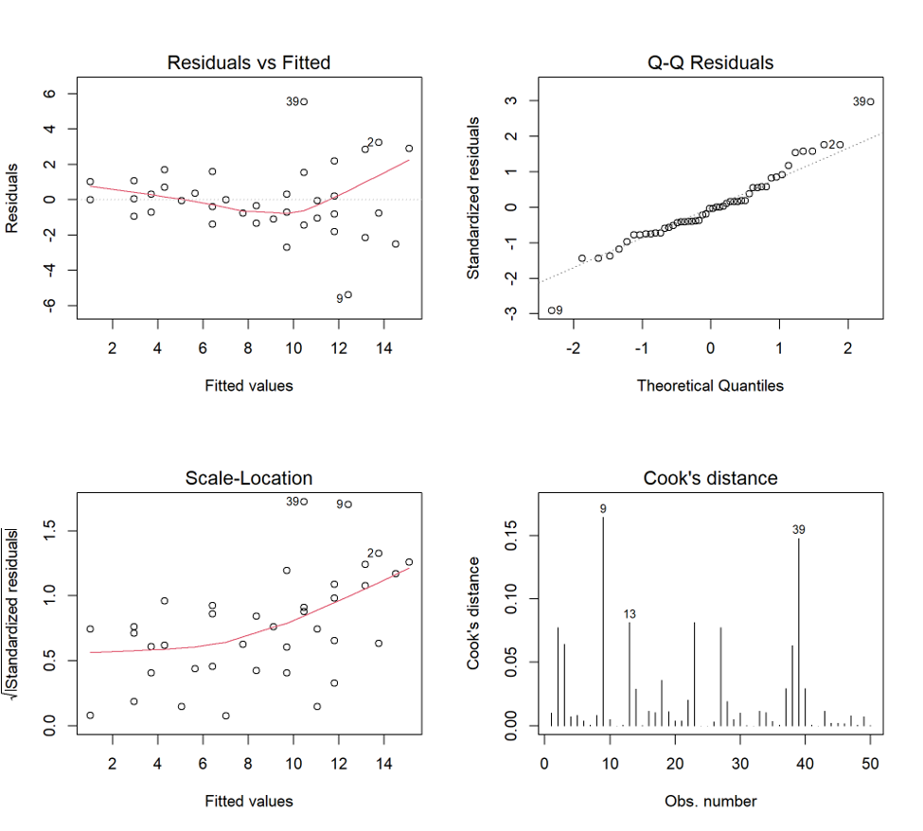
Suppl 1. Diagnostic Plots for the Primary Analysis of Covariance Model of Day-7 NIHSS Score.
(A) shows residuals plotted against fitted day-7 NIHSS scores, with a locally estimated smoothing (LOESS) curve (red line) and a horizontal reference line (dashed) to assess linearity. The smoothing curve shows no substantial systematic departure from linearity. Observations 9 and 39 had the largest residuals. (B) shows standardized residuals plotted against theoretical normal quantiles (Q-Q plot) to assess the normality of the residuals. Observation 39 showed the greatest deviation in the upper tail. (C) shows the square root of the absolute standardized residuals plotted against fitted values to assess the constancy of residual variance. Heteroscedasticity-consistent (HC3) standard errors were therefore used for the treatment-effect estimate in the sensitivity analysis. Observations 2, 9, and 39 had the largest scaled residuals. (D) shows Cook's distance for each observation. Observations 9 and 39 had the largest values (approximately 0.17 and 0.15, respectively), with observation 13 also labeled. None exceeded the prespecified threshold of 4/n (approximately 0.08 for 50 observations). The diagnostic plots showed no major departure from linearity or normality and identified mild heteroscedasticity but no highly influential observations. Abbreviations: HC3, heteroscedasticity-consistent version 3; NIHSS, National Institutes of Health Stroke Scale; Q-Q, quantile-quantile.

