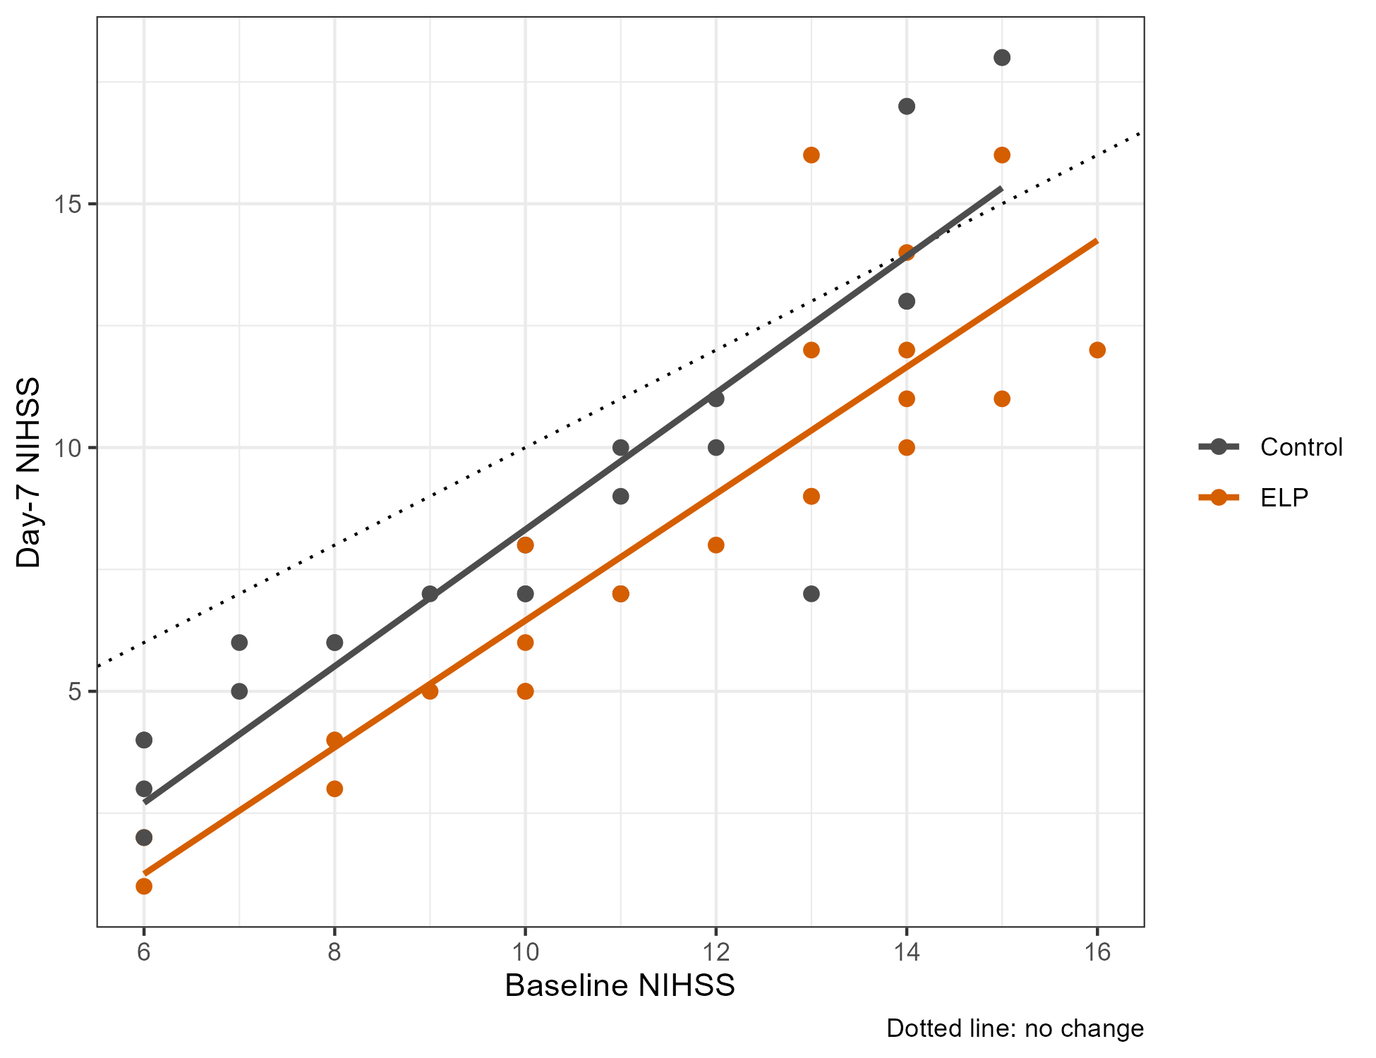

Suppl 2. Relationship Between Baseline and Day-7 NIHSS Score According to Treatment Group.
Scatterplot of day-7 NIHSS score versus baseline NIHSS score for the 50 randomized participants, according to treatment group. Solid lines indicate the fitted linear relationships between baseline and day-7 NIHSS scores within the control and elevated leg positioning (ELP) groups. The dashed diagonal line represents no change in NIHSS score from baseline to day 7 (day-7 NIHSS score equal to baseline NIHSS score); observations below this line represent a reduction in NIHSS score from baseline to day 7. Across the observed range of baseline NIHSS scores, the fitted line for the ELP group was below that for the control group, corresponding to lower predicted day-7 NIHSS scores at a given baseline NIHSS score. Abbreviations: ELP, elevated leg positioning; NIHSS, National Institutes of Health Stroke Scale.

